Cloud Notes App

Name | Roll No.
Swaraj Ambawade | 23CO008
Farhan Ansari | 23CO011
Yash Bhalodiya | 23CO014

Abstract

Cloud Notes is a full-stack cloud-based notes management web application developed as a Laboratory Practice II (LP-II) mini project for the Cloud Computing course (Semester VI, Computer Engineering). The application leverages a multi-cloud architecture combining Google Firebase and Amazon Web Services (AWS) to deliver a secure, scalable, and real-time note-taking experience.
Firebase Authentication provides secure email/password-based user management, while Firebase Firestore serves as a real-time NoSQL database for storing note content. The frontend is hosted globally via Firebase Hosting. For file attachments such as PDFs, images, and documents, AWS S3 is used as a durable object storage backend. To ensure that AWS credentials are never exposed in the browser, an AWS Lambda function generates temporary presigned URLs through an AWS API Gateway endpoint, enabling secure direct-to-S3 uploads and downloads.
This project demonstrates practical implementation of cloud computing concepts including Authentication as a Service (AaaS), Database as a Service (DBaaS), Serverless Computing (FaaS), Object Storage as a Service, and multi-cloud integration. The live deployment is accessible at: https://cloud-notes-app-d4219.web.app

Table of Contents

Contents
Abstract 2
Table of Contents 3
1. Introduction 4
2. Objectives 4
3. System Architecture 5
4. Technologies Used 6
5. Project Structure 7
6. Firebase Setup 8
7. AWS S3 & Lambda Setup 9
8. User Interface Screenshots 10
8.1 Login / Sign-in Page 10
8.2 Note Creation / Editor 11
9. Firestore Data Model 12
10. Features & Functionality 13
11. Deployment & Running Locally 13
12. Conclusion 14
13. References 14

Introduction

Cloud computing has revolutionized the way modern applications are built and deployed. By leveraging the infrastructure, platforms, and services provided by cloud providers, developers can build highly scalable, available, and secure applications without managing physical hardware.
Cloud Notes is a beginner-friendly demonstration of these cloud computing paradigms. Built as part of the LP-II Cloud Computing laboratory curriculum at AISSMS College of Engineering, Pune (under SPPU), this project integrates multiple cloud services to provide a complete notes management experience.
The application allows users to sign up, log in, create and manage personal notes, and optionally attach files. It demonstrates real-world usage of Firebase (Google Cloud) for authentication, database, and hosting, alongside AWS S3 and Lambda for secure file storage — making it a true multi-cloud application.
Live Application: https://cloud-notes-app-d4219.web.app

Objectives

- Implement user authentication using Firebase Authentication (Authentication as a Service)
- Store and retrieve notes in real time using Firebase Firestore (NoSQL DBaaS)
- Host the frontend application using Firebase Hosting (PaaS/CDN)
- Store file attachments (PDFs, images, documents) securely in AWS S3
- Use AWS Lambda and API Gateway to generate presigned URLs, keeping AWS credentials off the browser
- Demonstrate multi-cloud integration by combining Google Firebase and Amazon AWS
- Build a responsive, user-friendly frontend using pure HTML, CSS, and JavaScript

System Architecture

The architecture follows a serverless, multi-cloud design pattern. The browser client interacts with three main cloud backends: Firebase for authentication and data, and AWS for file storage via a Lambda proxy.

Architecture Flow:
- User's browser communicates with Firebase Authentication for login/signup
- Notes are read/written directly to Firebase Firestore using real-time listeners
- When a file attachment is needed, the browser requests a presigned URL from AWS API Gateway
- AWS API Gateway triggers an AWS Lambda function which generates a temporary S3 presigned URL
- The browser uploads the file directly to AWS S3 using the presigned URL
- The S3 object key is stored in the Firestore note document for future retrieval
- AWS credentials are never exposed to the browser — all key operations happen inside Lambda

Architecture Diagram (Text Representation):
|
Firebase Auth
User Browser
|
|
Firestore
AWS API Gateway
|
AWS Lambda (Presign)
| AWS S3 Bucket

Technologies Used

Technology | Category | Purpose
Firebase Authentication | AaaS | Secure email/password user login and signup
Firebase Firestore | NoSQL DBaaS | Real-time note storage and retrieval
Firebase Hosting | PaaS / CDN | Global frontend deployment
AWS S3 | Object Storage | Storing user file attachments
AWS Lambda | FaaS (Serverless) | Generating temporary presigned URLs
AWS API Gateway | API Management | HTTP API endpoint for Lambda invocation
HTML / CSS / JS | Frontend | Responsive single-page app UI
Node.js | Runtime | Lambda function runtime environment

Project Structure

The project follows a simple single-directory structure suitable for Firebase Hosting. All frontend files are in the root directory, while Lambda functions are in a separate subfolder.

File / Folder | Description
index.html | Main single-page application HTML file
styles.css | Responsive CSS styling for the application
app.js | Core application JavaScript: auth, notes CRUD, S3 upload
firebase-config.js | Firebase project credentials and S3 API URL configuration
firebase.json | Firebase Hosting and Firestore configuration
firestore.rules | Firestore security rules (per-user data isolation)
functions/aws-s3-presign-lambda.js | AWS Lambda function for generating presigned URLs
functions/package.json | Lambda function Node.js dependencies

Firebase Setup

Follow these steps to configure Firebase for the Cloud Notes application:

Step-by-Step Setup:
- Create a Firebase project at console.firebase.google.com
- Enable Authentication → Sign-in method → Email/Password
- Create a Firestore database (start in test mode, then apply security rules)
- Register a Web App in Firebase Project Settings and copy the config object
- Paste the Firebase config into firebase-config.js in the project root
- Install Firebase CLI: npm install -g firebase-tools
- Login: firebase login and connect: firebase init hosting firestore
- When prompted for public directory, enter '.' (current directory)
- Deploy Firestore security rules: firebase deploy --only firestore:rules

Firestore Security Rules:
The Firestore rules ensure that each user can only access their own notes, preventing unauthorized data access:

match /users/{userId}/notes/{noteId} {
allow read, write: if request.auth.uid == userId;
}

AWS S3 & Lambda Setup

The AWS backend handles secure file storage through a presigned URL pattern, ensuring AWS credentials never reach the browser.

S3 Bucket Configuration:
- Create an S3 bucket (e.g., cloud-notes-attachments-yourname) in ap-south-1 region
- Configure CORS settings to allow browser uploads from your Firebase Hosting URL
- Allow GET and PUT methods for the Firebase app origin and localhost for testing

IAM Role for Lambda:
- Create an IAM role with permission to PutObject and GetObject on the S3 bucket
- Scope the permission to the notes/* prefix within the bucket for security

Lambda Function Setup:
- Create an AWS Lambda function using Node.js 20 (or Node.js 18)
- Upload the code from functions/aws-s3-presign-lambda.js with its dependencies
- Set environment variables: AWS_REGION, S3_BUCKET_NAME, and ALLOWED_ORIGIN

API Gateway Configuration:
- Create an HTTP API in API Gateway and connect it to the Lambda function
- Add routes: POST /presign and OPTIONS /presign (for CORS preflight)
- Copy the API Gateway invoke URL into S3_PRESIGN_API_URL in firebase-config.js

Security Design Principle:
The browser never stores or sees AWS access keys. Instead, it requests a temporary presigned URL from the Lambda function (via API Gateway), uses it to upload directly to S3, and stores only the S3 object key in Firestore. When downloading, Lambda generates a short-lived download URL. This design follows the principle of least privilege and keeps credentials server-side only.

User Interface Screenshots

The following screenshots show the live application running at https://cloud-notes-app-d4219.web.app

Login / Sign-in Page

The login page presents a clean sign-in form with email and password fields. Users can also create a new account from this screen.

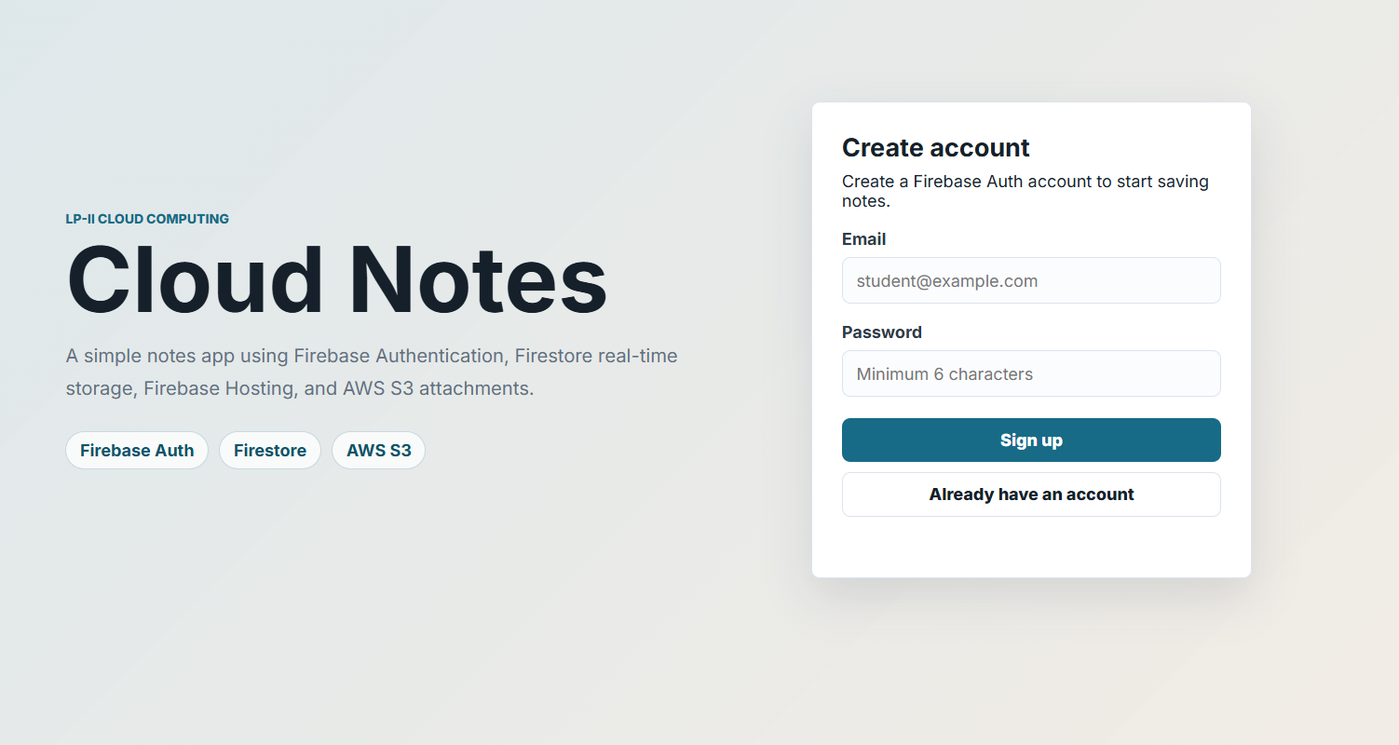
Figure 1: Cloud Notes Login Page

Note Creation / Editor

After logging in, users see the Personal Workspace dashboard with a Note Editor allowing them to create notes with a title, content, and optional file attachment.

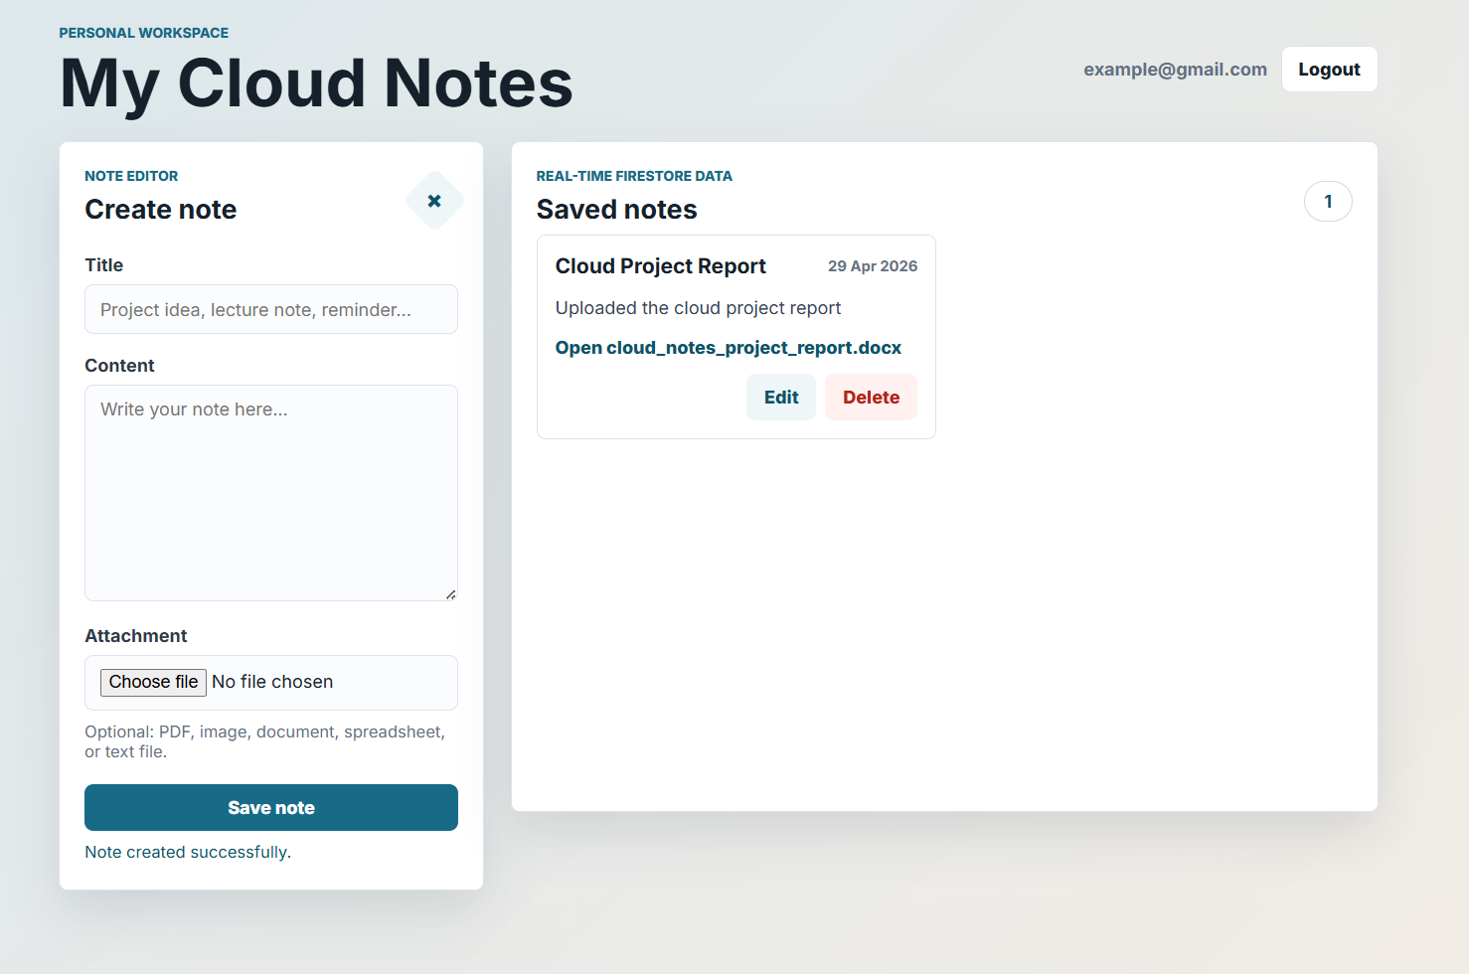
Figure 2: Cloud Notes - Create Note Editor with File Attachment

Firestore Data Model

Notes are stored in a hierarchical Firestore collection scoped per user, ensuring data isolation:

Collection Path: users/{userId}/notes/{noteId}

{
"title": "Cloud computing assignment", "content": "Prepare Firebase and AWS S3 demo.", "createdAt": <server timestamp>,
"updatedAt": <server timestamp>, "attachment": {
"name": "diagram.pdf", "type": "application/pdf", "size": 45678,
"key": "notes/userId/1719000000000-diagram.pdf"
}
}

Key Design Decisions:
- The attachment field is optional — notes without files simply omit it
- Only the S3 object key is stored in Firestore, not the full URL (URLs are generated on demand)
- Server timestamps (FieldValue.serverTimestamp()) are used for consistency across time zones
- Each user's data is stored under their UID path, enforced by Firestore security rules

Features & Functionality

- User signup and login with Firebase Authentication (email/password)
- Create, edit, delete, and view personal notes
- Real-time note updates using Firestore real-time listeners (onSnapshot)
- Upload optional attachments: PDFs, images, documents, spreadsheets
- Secure file storage in AWS S3 via Lambda presigned URLs
- Attachment download links generated on demand (short-lived, secure)
- Fully responsive design — works on mobile and desktop browsers
- User-scoped data — each user sees only their own notes
- Deployed live on Firebase Hosting with global CDN

Deployment & Running Locally

Local Development:
To run locally using Firebase Emulator:
$ firebase serve # or
$ firebase emulators:start --only hosting # Open: http://localhost:5000

Production Deployment:
$ firebase deploy
# Deploys to: https://cloud-notes-app-d4219.web.app

Conclusion

The Cloud Notes application successfully demonstrates a practical implementation of cloud computing concepts using a multi-cloud architecture. By combining Firebase (Google Cloud) for authentication, real-time database, and hosting with AWS S3 and Lambda for secure file storage, the project showcases how modern web applications leverage multiple cloud services to build scalable, secure, and feature-rich solutions.
The application highlights several important cloud computing paradigms: Authentication as a Service removes the complexity of user management, Database as a Service with Firestore enables real-time data synchronization, Platform as a Service through Firebase Hosting ensures global content delivery, and Serverless computing via AWS Lambda eliminates server management overhead. The presigned URL pattern demonstrates a secure, production-ready approach to handling file uploads without exposing cloud credentials.
This project provided hands-on experience in integrating multiple cloud platforms, configuring IAM roles and policies, implementing security rules, and deploying a full-stack application. The skills gained are directly applicable to real-world cloud application development scenarios.

References

- Firebase Documentation — https://firebase.google.com/docs
- AWS S3 Developer Guide — https://docs.aws.amazon.com/s3
- AWS Lambda Developer Guide — https://docs.aws.amazon.com/lambda
- AWS API Gateway Documentation — https://docs.aws.amazon.com/apigateway
- Firestore Security Rules Guide — https://firebase.google.com/docs/firestore/security/get-started
- Live Project: https://cloud-notes-app-d4219.web.app

